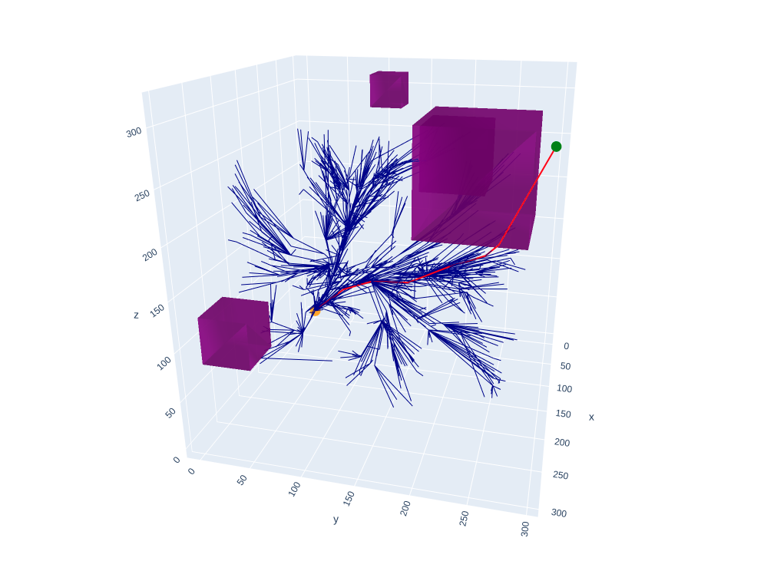

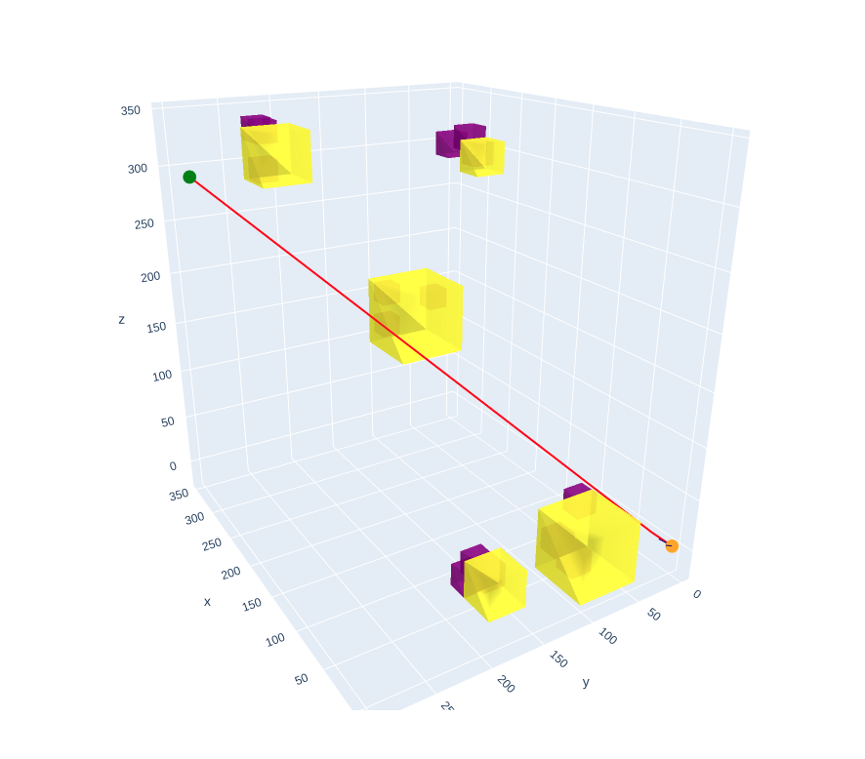

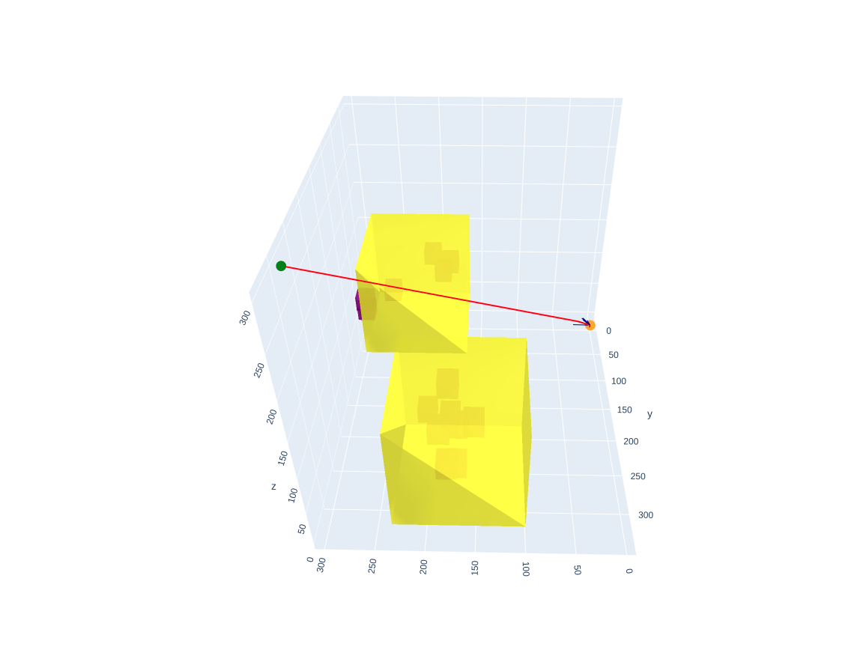

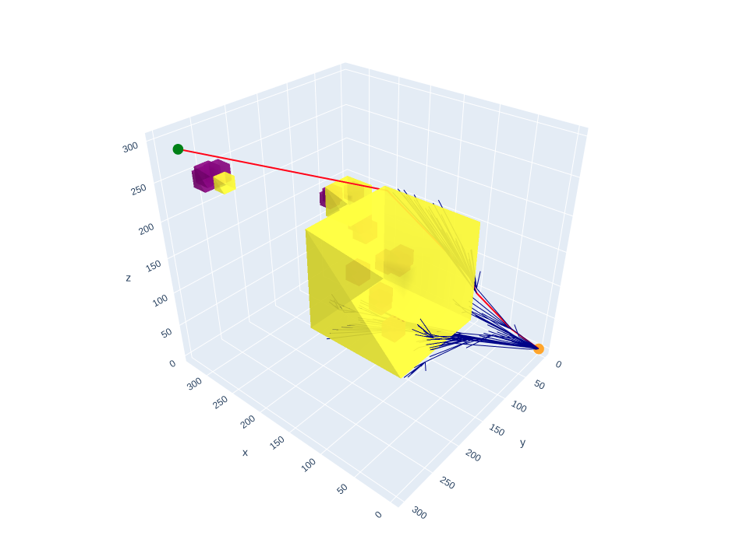

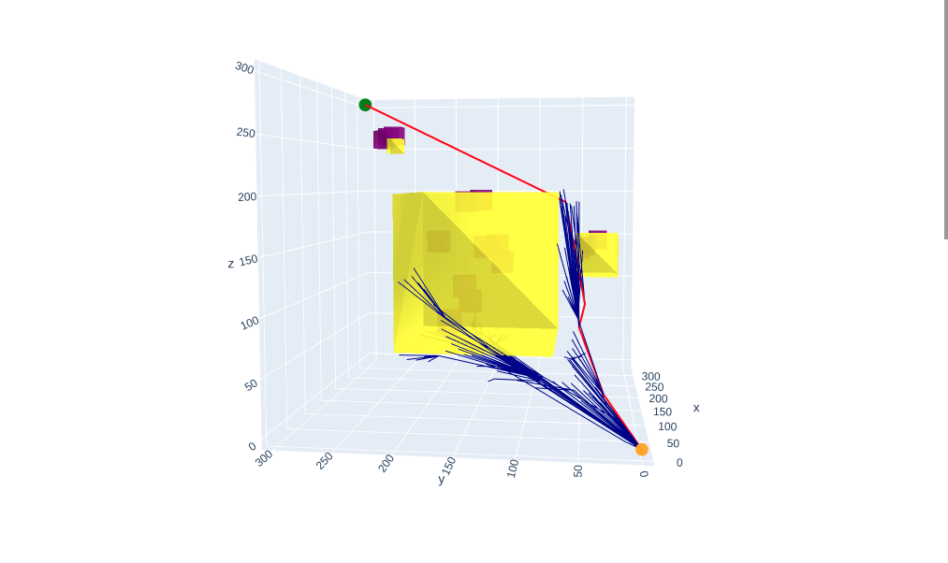

Work
Test cases for randomly generated point
Test cases for randomly generated clusters from randomly generated cluster centers
Finding cluster's points close to the circumference points
Clustering algorithm
Clustering the 3d point cloud, finding the center and the radius of the cluster with that creating solid objects from dense point cloud clusters
Making sure that the point is actually never near the obstacles
Switching to OOP

